CURRICULUM NEWSLETTER SONGANI CLASS (RECEPTION)
TERM 3 2023/2024

Friday 19th April 2024

Hey there, Songani Superstars!

🌟 Welcome back to our awesome class! Did you have a super-duper break? We sure hope so! 🎉 We're all geared up for a term packed with amazing adventures in learning, and guess what? You're coming along with us! How cool is that? 😄 So, gather 'round, because I've got some super exciting stuff to share with you about all the fun things we have planned! 📚🎨🌟 some information about what we have in store for you.

OUR TOPIC THIS TERM
Get ready to celebrate, everyone! 🎉 This term, our theme is all about "Celebrations"! 🥳 We're diving into a world of festivities from every corner of the globe. 🌍 Because guess what? Our planet is like a treasure chest filled with countless cultures, traditions, and stories just waiting to be explored! 🎉✨
We're going to have a blast exploring all sorts of celebrations in every subject area! 📚 From whipping up delicious foods to crafting beautiful cards and sharing gifts, there's so much fun in store for us! 🎨🎁 So, get ready to party and learn in style, because this term is going to be an absolute blast! 🌟🎉

If the children show interest in other topics, we will also include these in our learning as we have an emphasis on child initiated learning in Reception.

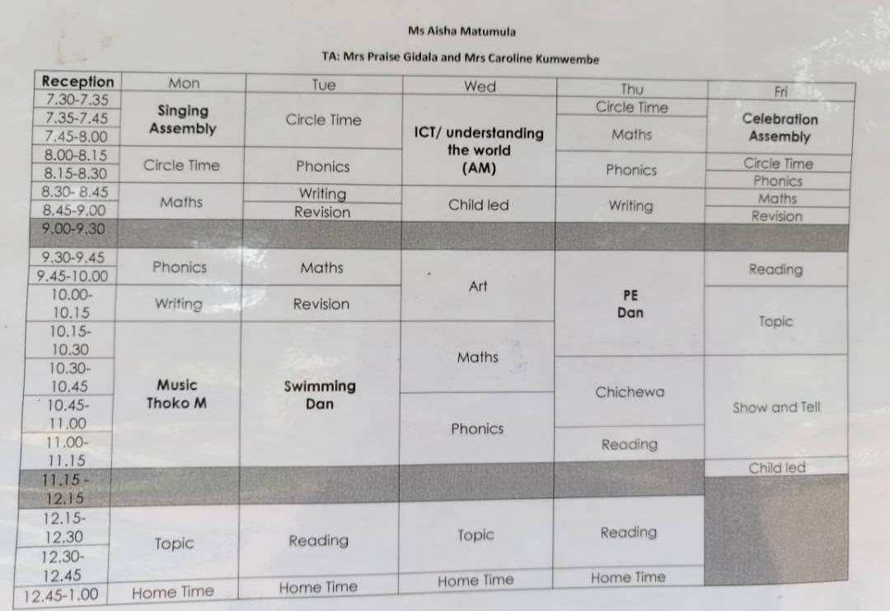
WEEKLY TIMETABLE
PE AND SWIMMING (Mr. Dan)

In PE, we’re focusing on the simple skills of hockey such as ball control and passing. Children are also learning various PE games aimed to help develop agility, balance and coordination for future skill development in a range of sports.

In Swimming, we’re focusing on the foundations of swimming such as confidence in the water, jumping & submerging (face in the water), breathing, kicking and floating.

Please make sure that your child brings their kits on the correct day.
On Tuesday we have Swimming.
On Thursday we have PE.

Please ensure that all items are clearly labelled with your child’s name including your child’s swimming towel.
Music, Dance and Drama (Mrs. Thoko K)

In music this term we are learning to sing rhythmically and create musical sounds.
In dance and drama we are learning simple dances that will help build confidence to perform in groups.

UNIFORM
Please ensure that all items are clearly labelled with your child’s name. This really helps us to identify items quickly and ensure the correct uniform is the with right child.

TIMINGS OF THE SCHOOL DAY

Please note that school starts every day promptly at 7:30am. It is crucial to your children’s education to be at school on time so they do not miss out on their learning. Please arrive promptly on time at the end of the school day to pick up your child. This is at 12:45pm Monday – Thursday and 11.45am on a Friday.
Day of the week | School begins at: | School finishes at: | Please remember:
Monday | 7.30am | 1pm | -
Tuesday | 7.30am | 1pm | Swimming/Fine Motor
Wednesday | 7.30am | 1pm | -
Thursday | 7.30am | 1pm | PE kit
Friday | 7.30am | 11.45am | Show and Tell

HOMEWORK

Each week, a new book is placed in the homework folder along with Math and English worksheets, Reading Rockets materials, and spelling/writing exercises. Please provide your feedback or notes in the green reading exercise book provided weekly. Remember to send the homework folder back to school every day.

Miss Aisha

