CURRICULUM NEWSLETTER TERM 3 2023/24
Chiradzulu Class
17.4.2024
Dear Parents,
Welcome back! We trust you had a good break over Easter and are ready for the final term of Year 1 ! It’s hard to believe we are here already! We would like to take this opportunity to give you some information about the exciting learning that will take place this term.

OUR TOPIC
This term our topic is “ Reduce, Re-use, Recycle – The 3 R’s and Let’s Celebrate” . Our key texts will be: 10 ways I can help the earth by Melanie Walsh, Somebody Swallowed Stanley by Sarah Roberts as well as Let’s Celebrate – a look at a variety of celebrations across the world . We will be exploring this topic through the following aspects of learning:

In Literacy – The children will complete a variety of reading and writing tasks relating to fiction and non- fiction genres. A simple non-fiction report will be produced and we will also be introduced to letter writing, using The Jolly Postman as our inspiration. In Grammar, we will be looking at adverbs, tenses and contractions, as well as compound words. . We will continue using correct punctuation such as exclamation marks, question marks and full stops. We will encourage more content in our creative writing using adjectives and descriptive language to make an exciting story. To link in with our topic, we will be focusing on opinion writing.

In Mathematics – We will continue to develop number skills including counting in steps to and across 100, partitioning numbers into tens and units and developing quick recall of number facts. We will also focus on mental and written strategies to add and subtract, as well as starting to understand division and multiplication. This will all be introduced and reinforced with hands on practical activities, making arrays, repeated addition, sharing equally and division with remainders. We always start with the concrete, using plenty of manipulatives before moving onto the more abstract concepts.

In Science – We will be exploring, identifying, classifying and contrasting materials to link in with our topic of what can be recycled or re-used. We will investigate the various properties of a variety of materials as well as carrying out simple scientific experiments.
In Geography - Our focus will be on map work, recognizing - north, south, west, east , creating a simple map using relevant symbols in the key. We will revisit key human and physical geographical features.
In History – Changes within living memory. To link in with our celebration theme, we will be looking at celebrations with local significance in Malawi, Independence day, John Chilembwe day, various religious festivals. We will also be peeping into the past by learning about toys and games from long ago and comparing them to what we have today.
In RE – RE is an important curriculum subject. It is important in its own right and also makes a unique contribution to the spiritual, moral, social and cultural development of pupils. This term we will be focusing on Christianity .

In Music – Composition. Make percussion and tuned instruments and experiment with different sounds. Play instruments along to known songs, looking at songs with different tempo and dynamics. Most of this term will be focused on practicing for our KS1 production.
In PE –We will continue to swim as long as the weather allows, however, once it is too cold to continue swimming we will switch to gym. You will be advised when we change. In PE, we will continue to participate in ball skills and team games. PE is every Wednesday.
In Art and DT – We will be learning about famous artists such as Van Gogh, Miro, Andy Goldsmith and Maurice Sendak. We will look at their own unique styles and produce our own masterpieces. Much focus this term will be on using recycled items to make a variety of creations to fit in with our topic. DT this term is textures and textiles.
In ICT : We will learn how to create images on the computer and continue with position and direction using Beebots.

HOMEWORK 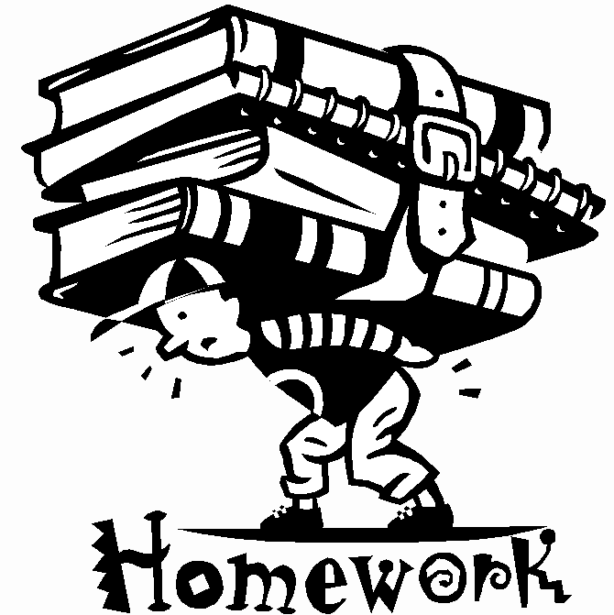
A weekly homework will be sent home every Thursday to be completed by Monday. This will include either: an investigative activity linked with our topic or an activity with a maths or literacy focus. Spelling Spiders, Maths Monkeys and Reading rockets will continue to be practiced daily as well as the class spelling. These will be reviewed and tested on Fridays as well as their weekly spelling words. Kindly return library books every Friday, so your child can choose a new one.
It would be highly beneficial if you could read with your child every day for at least 10 minutes as this will not only improve their reading but also their writing skills. Visit www.oxfordowl.co.uk – it is a fabulous online reading website.

IMPORTANT INFORMATION
Please note that school starts every day promptly at 7:30am. It is crucial to your children’s education to be at school on time as all our core subjects (Literacy and Mathematics) begin at that time. We have 1 short break and a longer lunch break. Please ensure that your child has enough snacks and water for these times. We encourage healthy snacks and appreciate your support in limiting sugar. No sweets or fizzy drinks are allowed. Kindly clearly LABEL every item that belongs to your child. It’s important to remember that we finish at 11.45 a.m. on Fridays. Thanks for your co-operation with this.

